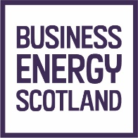
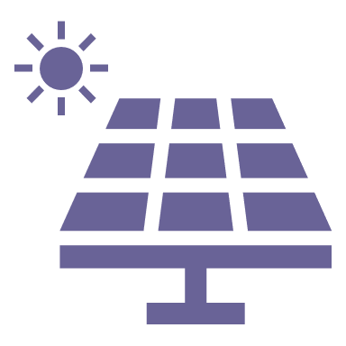
Business Energy Scotland Solar PV fast track support request form

Thank you for enquiring about
free support from Business Energy Scotland

We are funded by the Scottish Government to help small and medium-sized enterprises use energy more efficiently, reduce their carbon footprint and save money.
With our solar PV fast track support, we can help you quickly understand how suitable solar PV technology could be for your business.

- To verify your eligibility for this free support, please complete this form in FULL.

- When completing by hand please use BLOCK CAPITALS.

- If you require assistance completing the form, please phone 0808 808 2268 and we will be happy to support you.

This form is not an application for a loan from
the Scottish Government’s SME Loan Scheme

Our support can result in the provision of a qualifying report to support an application to the Scottish Government’s SME Loan Scheme.
If you already have a qualifying report and are now looking to apply for a loan from the Scottish Government’s SME Loan Scheme, you can download an application form here.

Section A – About you and your business
Contact information:
Contact name
Job title
Phone number
Mobile
Email address
Website address
Keep up to date with the latest grants and funding, case studies, and free training opportunities  Tick/select to receive our monthly newsletter, the Bottom Line, and other useful business e-updates |  | ☐

Business information:
Enterprise name
Company number/Charity registration number
Trading start date | Day |  |  |  | Month |  |  |  | Year
Legal structure | ☐ Sole trader |  |  | ☐ Partnership |  |  | ☐ Limited | ☐ Non limited |  |  | ☐ Reg. charity
 | ☐ Other, please specify:
Registered address, including postcode

Eligibility information: To receive support, we must be able to demonstrate that your enterprise is classed as a small or medium-sized enterprise (SME).
No of full-time equivalent employees on site
No of full-time equivalent employees in entire enterprise
Turnover of enterprise  (from last accounts) |  | £ |  |  |  |  | Balance sheet total  (from last accounts) |  |  |  |  |  |  |  |  |  |  |  | £
Date of last accounts |  | Day |  |  |  |  | Month |  |  |  |  |  |  |  |  |  |  |  | Year
Is your enterprise wholly or partly owned by another organisation (this includes parent or holding companies)? |  |  |  |  |  |  |  |  |  |  |  | ☐ Yes |  |  |  |  |  |  | ☐ No
Does your enterprise own any subsidiaries? |  |  |  |  |  |  |  |  |  |  |  | ☐ Yes |  |  |  |  |  |  | ☐ No
If you answered ‘yes’ to either of the two previous questions, please provide further information on the ownership structure of your enterprise:

Project background information
Section B - Your site
Are you looking at solar PV for a new build? |  |  |  |  | ☐ Yes |  |  | ☐ No
If yes, do you have architect plans? |  |  |  |  | ☐ Yes |  |  | ☐ No
Site address
(If different from the registered address provided above in section A, please provide the address of the site you would like to improve.)
Section C - Available land
Do you have land where you could install  ground mounted solar PV panels? |  |  |  |  | ☐ Yes |  |  |  | ☐ No |  |  |  |  |  |  |  | If no, go to section D
If yes, what is the approximate square meterage of land available? |  |  |  |  |  |  |  |  |  |  |  |  |  |  |  |  |  |  |  |  |  | m2
Section D - Available roof space
Do you have space where you could install  roof mounted solar PV panels? |  |  |  | ☐ Yes |  |  |  |  |  | ☐ No |  |  |  |  |  |  | If no, go to section E
What is the approximate square meterage of roof space available? |  |  |  |  |  |  |  |  |  |  |  |  |  |  |  |  |  |  |  |  |  | m2
Are any of the buildings that the solar panels could be installed on  classified as ‘listed’ or in a ‘conservation area’? |  |  |  |  |  |  |  |  |  |  |  |  |  |  |  |  | ☐ Yes |  |  | ☐ No
Is the roof space flat? |  |  |  |  |  |  |  |  |  |  |  |  |  |  |  |  | ☐ Yes |  |  | ☐ No
If your roof isn’t flat, what direction does it face?  Note: we would not recommend installing  solar PV on a north facing roof. |  |  |  |  |  | ☐ South |  |  |  |  |  |  |  |  |  |  | ☐ East |  |  |  | ☐ West
 |  |  |  |  |  | ☐ Southeast |  |  |  |  |  |  |  |  |  |  | ☐ Southwest
If your roof isn’t flat, at what angle does it slope approximately? |  |  |  |  |  | ☐ 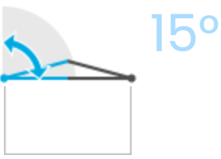 |  |  |  |  |  |  |  |  |  |  |  | ☐ 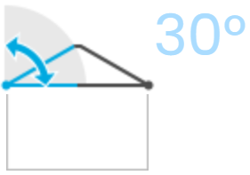 |  |  |  |  |  | ☐ 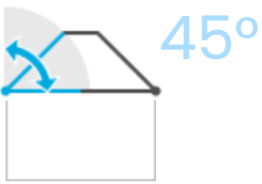
 |  |  |  |  |  | ☐ 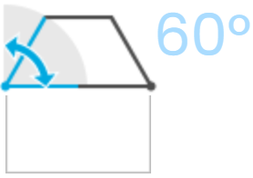 |  |  |  |  |  |  |  |  |  |  |  | ☐ 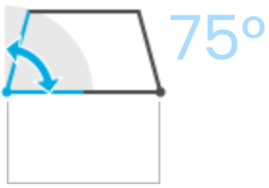
Section E - Current electricity use
It is critical to understand your current electricity use when assessing solar PV. When submitting this form, unless you are a new business/site, please include 12 months’ of electricity billing information.
Approximately, what is your current annual electricity cost? |  |  |  |  |  |  |  |  |  | £
Do you use electricity for your space heating? |  |  |  |  |  |  |  |  |  | ☐ Yes |  |  |  |  | ☐ No
When do you use electricity? |  |  |  |  | ☐ 24 hours |  |  |  |  |  |  |  |  | ☐ Daytime only |  |  |  |  |  |  |  |  | ☐ Evening only
Section F - Quotes
Do you have or are actively obtaining quotes from suppliers for the installation of solar PV |  |  |  |  |  | ☐ Yes (please provide copies, if available)  ☐ No
 | Section C – Additional information
 | How we use your information – please read prior to submitting this support request
Business Energy Scotland is collecting your information so that we can verify your eligibility for support from Business Energy Scotland, and to arrange the most appropriate support for your business.
This information may be shared with Scottish Government as funders of this service, and therefore may be subject to disclosure under the Freedom of Information (Scotland) Act 2002. We may contact you to ask for your feedback on your experience of our services to help us improve them.

For further information about how we use your data please see Business Energy Scotland’s privacy policy available here or from our Data Protection Officer by writing to DataProtectionOfficer@est.org.uk.

Please check you have provided
the following before submitting
- Answers to ALL questions ☐
- Electricity bills for the last 12 months ☐
- Quotes from suppliers ☐ (if available)

When ready, please return your completed form to
support@businessenergyscotland.org

Solar PV fast track support request form November 2022

